Practice Exam
Instructions: Answer all questions. Show calculations where required.
Total: 66 points

Section A – Short Answer, Multiple Choice, and True/False
1. (3 points) [Topic: Ranking Systems]
If two models produce identical score vectors, any monotone transformation leaves the ranking unchanged. (True/False)
True

2. (3 points) [Topic: Significance Testing]
Which of the following changes will increase the t-statistic (making it more likely to be significant)?
A. Decrease the sample size.
B. Increase the variance of each group.
C. Increase the difference between group means.
D. Decrease measurement precision.
C

3. (3 points) [Topic: Significance Testing]
The Kolmogorov–Smirnov test compares:
A. Variances
B. Means
C. CDFs
D. Correlations

CDFs
4. (3 points) [Topic: Descriptive Statistics]
Define the z-score and explain why it is unitless.
Answer: z = (x − μ)/σ; dividing by σ cancels measurement units.
Explanation: Standardization centers by μ and scales by σ, removing units.

5. (3 points) [Topic: Bias & Sampling]
Survivorship bias in data analysis refers to what phenomenon?
Answer: Analyzing only successful apps in an app store to infer what drives success ignores the many failed apps that never ranked.
Explanation: Only survivors are visible.

6. (3 points) [Topic: Data Cleaning]
Which pipeline order is generally most robust?
A. Model → Clean → EDA
B. EDA → Clean → Model → Validate
C. Standardize → Collect → EDA
D. Validate → Model → Collect
B

7. (3 points) [Topic: Correlation & Regression]
Spearman correlation is preferred when the relationship is monotonic but nonlinear. (True/False)
True
- Spearman correlation measures the monotonic relationship based on ranked values (ordered pairs).
They differ when the relationship is nonlinear but monotonic (e.g., exponential growth).

8. (3 points) [Topic: Descriptive Statistics]
iven Min=58, Q1=76, Median=82, Q3=86, Max=100, determine if there are outliers using the 1.5×IQR rule.
Answer: IQR = 86 − 76 = 10. Lower fence = 76 − 1.5×10 = 61; upper fence = 86 + 1.5×10 = 101. Min=58 < 61 ⇒ 58 is an outlier. Max=100 < 101 ⇒ not an outlier. Answer: Yes — 58 is an outlier.

The Interquartile Range (IQR) measures how spread out the middle 50% of data is.
IQR=Q3−Q1=86−76=10

The boxplot rule says:
- Any value below Q1−1.5×IQR is considered a low outlier.
- Any value above Q3+1.5×IQR
is considered a high outlier.
9. (3 points) [Topic: Correlation & Regression]
Explain one difference between Pearson and Spearman correlation.
Answer:
- Pearson correlation measures the strength of a linear relationship between numeric variables.
- Spearman correlation measures the monotonic relationship based on ranked values (ordered pairs).
They differ when the relationship is nonlinear but monotonic (e.g., exponential growth).

10. (3 points) [Topic: Ranking & Modeling]
In ELO ranking , what is the logistic function used to map a real-valued score to probability?
The logistic curve gives a smooth, S-shaped mapping:
- Large differences in rating → probability near 0 or 1.
- Small differences → close to 0.5.
It models uncertainty realistically, unlike a step function.

Section B – Long Answer
11. (6 points) [Topic: Distributions]
Describe a real-world variable fit by each of the following distributions with a labeled sketch: Geometric, Normal, Poisson, Power Law.

1. Geometric Distribution – “How many tries until success?”
Example:
Imagine flipping a coin until you get heads. The geometric distribution tells us the probability of needing 1 flip, 2 flips, 3 flips, and so on.
Real-world example:
How many sales calls a salesperson must make before getting the first “yes.”
2. Normal
Most people’s heights cluster around the average, with fewer very short or very tall people.
Real-world example:
Exam scores, IQ, weights — many natural phenomena follow this pattern.

Poisson:
Example:
The number of emails you receive per hour, or cars passing a checkpoint per minute.
Real-world example:
Counting the number of customer arrivals at a store in one hour.

Power Law
Power Law Distribution – “A few big ones, many small ones”
Example:
Think of city populations or social media followers: a few cities are huge, while most are small.
Real-world example:
Wealth distribution — a few people are extremely rich, while most have modest wealth.
Shape sketch (log scale):

12. (6 points) [Topic: Significance Testing]
Explain the statistical test a professor should perform to test if attendance improves final exam scores. Include steps to obtain a p-value.
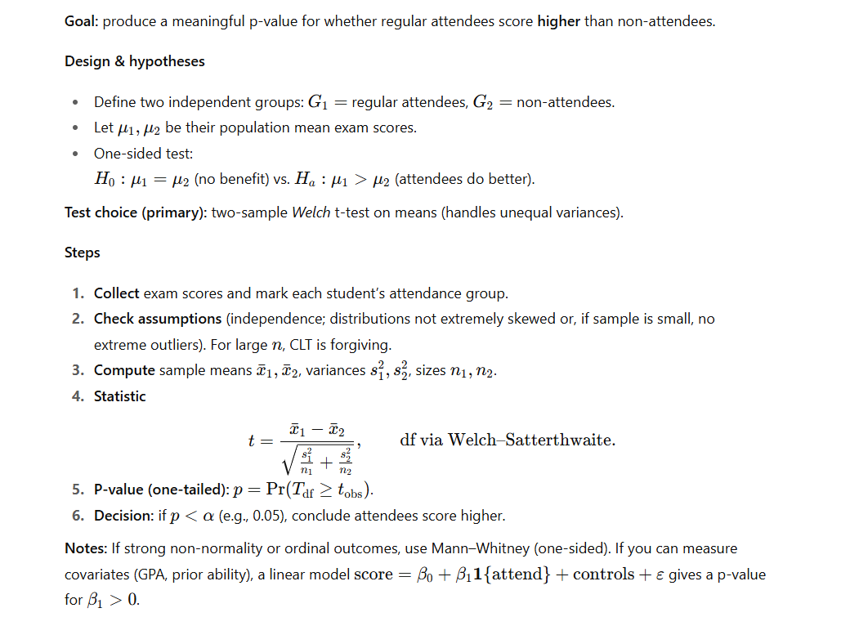
13. (6 points) [Topic: Time Series]
Explain two approaches to handle missing values in a temperature time-series when a) few points are missing, and b) a large block is missing.
- For rare missing points, interpolate from neighboring values to preserve local patterns (e.g., capture heat waves or cold spells).
- For a large missing patch, fill using a consensus from other years (e.g., the same dates in previous years).

14. (6 points) [Topic: Descriptive Statistics]
Compare the effects of deleting an outlier after computing z-scores on mean and standard deviation.
Answer:
Deleting an outlier after computing Z-scores breaks the normalization:
- The new mean will no longer be 0.
- The new standard deviation will drop sharply (since the outlier inflated σ).
- [1,2,3,4,1000]
Compute z score
Zscore x
Compute zscore after removing 1000

15. (6 points ) [Topic: Ranking & Modeling]
Consider the network in Figure 2. Determine the nodes with the smallest and largest rank after running the PageRank algorithm on the network. Briefly justify your answer.

